**Year 7 Knowledge Organiser- Special Places**

**Places of Worship**

A specific space where people of a religion gather to worship together, learn about their faith, and interact with their community

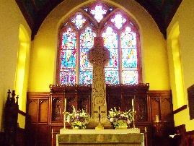 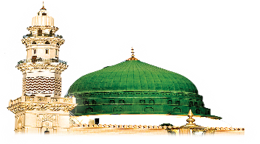 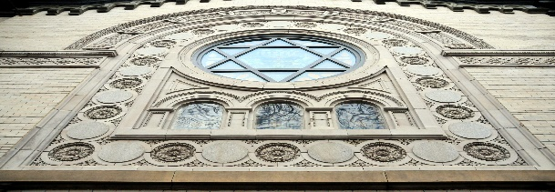

|  |  |
| --- | --- |
| **Christianity** | **Church/Cathedral** |
| **Islam** | **Mosque/Masjid** |
| **Judaism** | **Synagogue** |
| **Hinduism** | **Temple/Mandir** |
| **Sikhism** | **Gurdwara** |
| **Buddhism** | **Temple/Vihara** |

**Places of Pilgrimage**

A place that religious people travel to as a sign of devotion to their faith. Often a very spiritual journey. Usually to a sacred place or shrine.

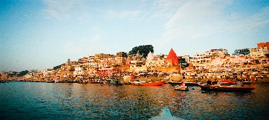 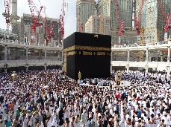 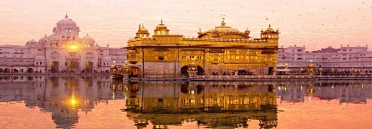

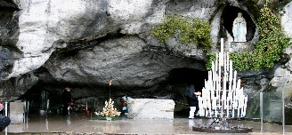

[This Photo](https://commons.wikimedia.org/wiki/File:Grotto_of_Lourdes_-_Lourdes_2014_(3).JPG) by Unknown Author is licensed under [CC BY-SA](https://creativecommons.org/licenses/by-sa/3.0/)

|  |  |
| --- | --- |
| **Religion** | **Examples of places of Pilgrimage** |
| Christianity | Lourdes, Jerusalem, Knock |
| Islam | Mecca, Medina, Mina, Jerusalem |
| Judaism | Jerusalem |
| Hinduism | Varanasi, River Ganges |
| Sikhism | Amritsar |
| Buddhism | Lumbini, Bodh Gaya |

|  |  |
| --- | --- |
| **Keywords** |  |
| **Secularism** | Being unrelated or completely neutral in terms of religion.  Some people think all institutions should be secular. |
| **Religious Pluralism** | A society that allows lots of different religions to coexist. This also applies to different groups or denominations within a singular religion.  (For example, Catholics; Protestants; Mormons; Baptists) |
| **Culturally religious** | Observing certain parts of a religion, such as festivals, family celebrations, or moral code, without necessarily believing in the spiritual part of the religion.  (For Example: being ethnically Jewish; Cultural Hinduism) |

