REPRESENTATIONS…

# @whisto_maths

Working in the Cartesian plane



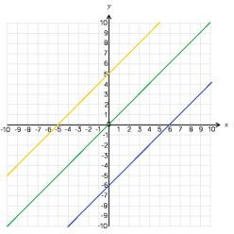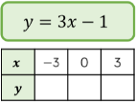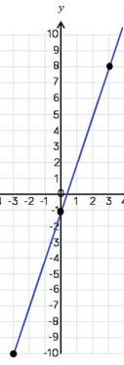

Remember to join the points to

make a line

Plotting more points helps you

decide if your calculations are correct (if they do make a straight line)

You only need two points to form

a straight line

This represents a coordinate pair

(-3, -10)

Draw a table to display this

information

-10 -1 8

Plotting y = mx + c graphs

3 x the x coordinate then – 1

5 has been added to each

of the x coordinates

This shows the translation

of that line.

e.g. y = x + 5 Is the line y=x moved 5 places up the graph

y = x + a

This is the line y=x when the y and x coordinate are the same

y = x

y = x - 6

y = x + 5

Lines in the form y = x + a

All the lines are parallel because the gradients are the same

|  |  |
| --- | --- |
|  | |
| Direct Proportion ysing y=kx  The line must be straight to be directly proportional – variables increase at the same rate k  Direct proportion graphs always start at (0,0) as they are describing relationships between two variables |  |
| Lines with negative gradients  Any straight-line graph with a negative x value has a negative gradient.  E.g. y = -2x  y = -x y + x = 12  Direction of all negative gradients |

What do I need to be able to do?

By the end of this unit you should be able to:

* Label and identify lines parallel to the axes
* Recognise and use basic straight lines
* Identify positive and negative gradients
* Link linear graphs to sequences
* Plot y = mx + c graphs

Keywords

Quadrant: four quarters of the coordinate plane.

Coordinate: a set of values that show an exact position. Horizontal: a straight line from left to right (parallel to the x axis) Vertical: a straight line from top to bottom (parallel to the y axis) Origin: (0,0) on a graph. The point the two axes cross

Parallel: Lines that never meet Gradient: The steepness of a line Intercept: tthere lines cross

|  |  |  |
| --- | --- | --- |
| Coordinates in four quadrants  y-axis  Coordinate (x, y) (6, 4)  x-axis from the origin this coordinate is 6 places along the positive x  axis and 4 places up the positive y axis.  (0, a) ttill be always be a point  (x, y) on the y axis. (a can be  any number)  Always the Always the  position on the position on the (a, 0) ttill be always be a point x axis first y axis second on the x axis. (a can be  any number) | Lines parallel to the axes All the points on this line have ‘a’ can be ANY positive  a x coordinate of 10 or negative value including 0  Lines parallel to the y axis take the form  Intersection x = a and are vertical  points  Lines parallel to the x axis take the form  y = a and are horizontal  All the points on this line have e.g. (3, -2) (7, -2) (-2, -2)  a y coordinate of -2 all lay on this line because the y coordinate is -2 | |
| Recognise and use the line y=x This means the x and the y  coordinate have the same value  Examples of coordinates on this line: (0, 0) (-3, -3) (8, 8)  The axes scale is important – if the scale is the  same y = x will be a straight line at 450 | | Recognise and use the lines y=kx The value of k changes the steepness  of the line  y = 3x y = x Note: y =x is the same as y=1x  y = ½ x The bigger the value of k the steeper the line will be.  They will always go The closer to 0 the value of k the closer the line through (0,0) will be to the x axis. |

