|  |  |  |
| --- | --- | --- |
| **Resources:**  Issuu.com Adobe Color  DaFont  Flat UI Color | The ultimate guide to understanding color theory in design | by DesignGuru  | Bootcamp |  |

|  |  |
| --- | --- |
| Flat Plan:  How to plan a magazine (using a flatplan) | Mock Up: |

|  |  |
| --- | --- |
| Media Blog: Magazine Convention - Layout | Anatomy of a Magazine Layout - Yes I'm a Designer |

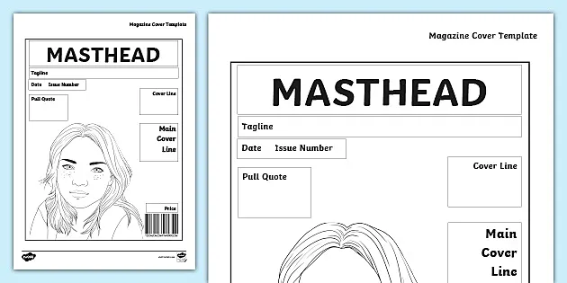 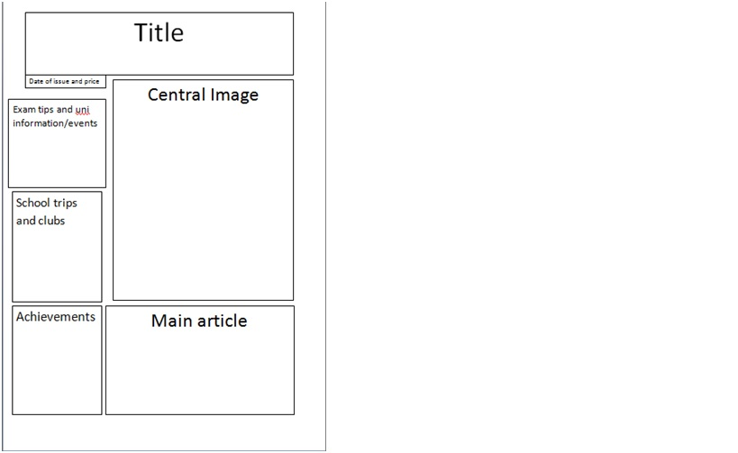

Cover Template Article Template