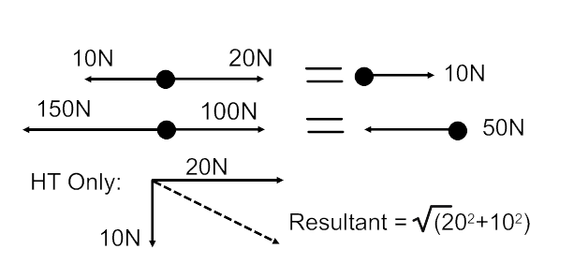

**-** Objects that move have a momentum. Momentum depends on the mass and velocity of the object.

- Momentum is always conserved. When objects collide, their total momentum before always equals their total momentum after.

Momentum (HT Only)

Springs

Basics

**PU5 – Forces**

**-** Work is a transfer of energy, so work done is energy transferred (J)

**-** Forces are **contact** when objects touch (ie friction) or **non-contact** when objects don’t touch (ie magnetism)

**- Scalars** have size only**:** distance, speed, time

**- Vectors** have size and direction**:** displacement, velocity, acceleration, force

- **Resultant vectors** in straight lines are found by adding/subtracting. At right angles you use Pythagoras (HT Only)

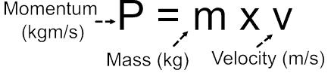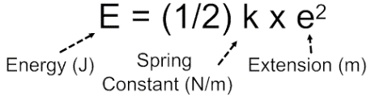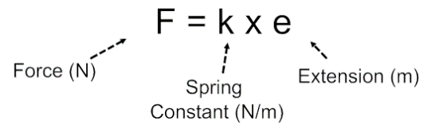

**-** Stretching a spring requires a force, so work is done. So, energy is stored in a stretched spring. The spring constant measures how much force is needed.

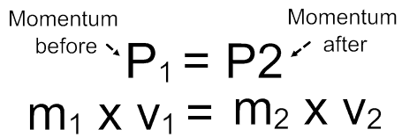

Speed and Acceleration

**-** Speed is rate of change of distance. Velocity is speed with a direction. Acceleration is rate of change of velocity

- Graphs: On distance/time graphs, the gradient= speed. On velocity/time graphs, the gradient= acceleration, and area under= distance

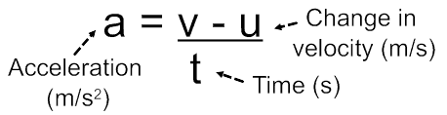

**-** Gravity is not a force; it is an interaction between masses. This creates a force called weight which pulls masses together.

- g =9.81N/kg on Earth, and is different on different planets/moons

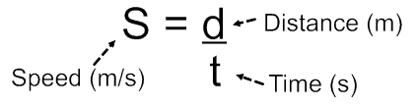

Stopping Distance

- Stopping distance = braking distance + thinking distance

Weight and Gravity

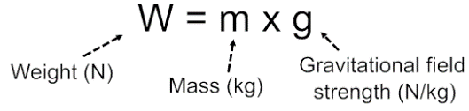

- Braking distance = distance travelled while the brakes are on. Affected by mass, velocity and things that affect friction (tyre or road conditions, weather, type of brakes etc)

- Thinking distance = distance travelled while reacting. Affected by velocity and things that affect reaction time (tiredness, distractions, drink/drugs etc)

Newton’s Laws

**-** Newton 1: resultant forces causes n acceleration. So, balanced forces mean objects remain stationary or move with constant speed.

- Newton 2:

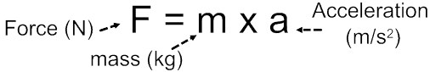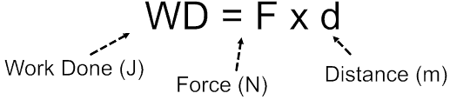

Work

- Newton 3: every force has an equal and opposite force.