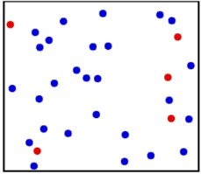

Molecules of a gas are in **constant, random** motion.

**Pressure in Gases**

**Specific Heat Capacity**

**PU3 – Particle model of matter**

Density

Density is a measure of how much mass is contained withing a given volume.

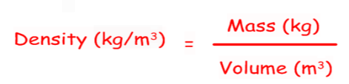

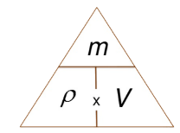

The molecules constantly collide with the walls of the container. This exerts a force on the container. The total of these forces is the pressure.

The closer the particles in a substance, the denser it is.

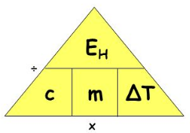

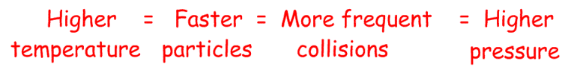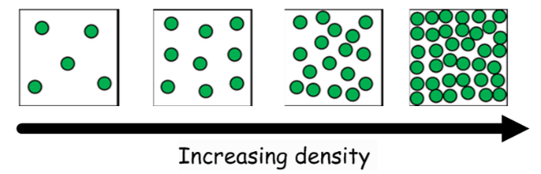

**Specific Latent Heat**

The above, plus:

**Physics Only:**

When a substance changes state, energy is needed. This energy breaks the bonds (solid to liquid to gas), or makes new ones (gas to liquid to solid.)

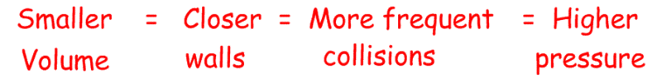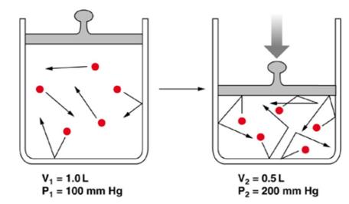

Heat and Temperature

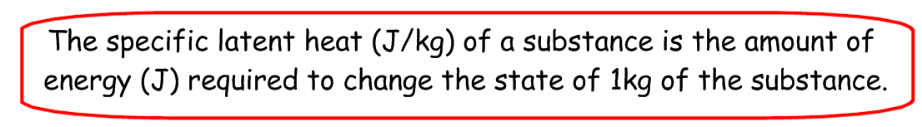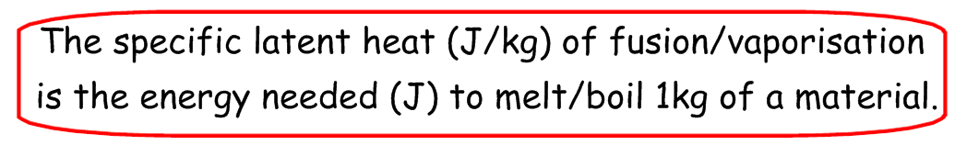

**Heat** = a form of energy stored in materials. Measured in Joules.

**Temperature** = a measure of the average kinteic energy of the particles in a substance. Measured in oC.



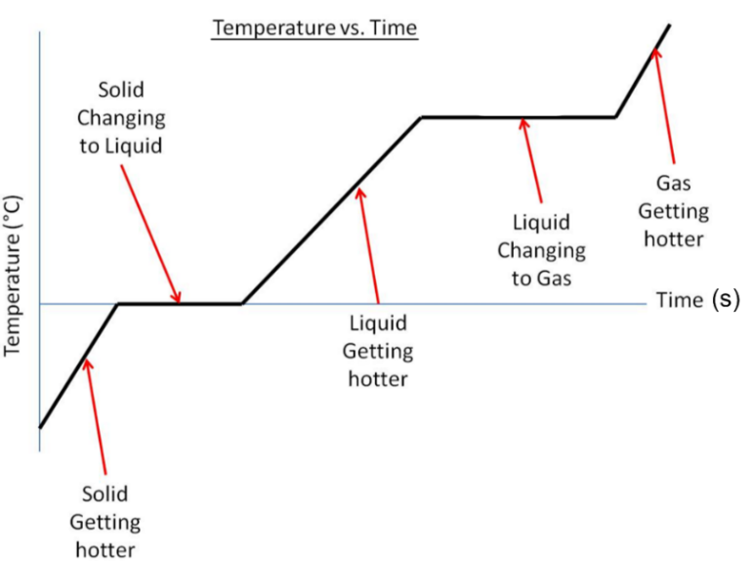

**Physics HT Only:**

The above, plus:

**Internal Energy**

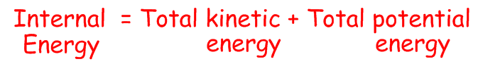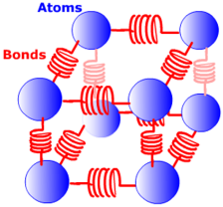

**Work is a transfer of energy.**

So, doing work on a gas transfers energy into the gas. This increases the gas’s internal energy.

As internal energy increases, the kinetic energy of the particles increases.

So, the temperature of the gas will increase.

**Doing work on a gas increases it’s temperature.**

All materials store energy:

- The particles have kinetic energy

- The bonds have potential energy

