Hormone | Produced | Role
FSH (follicle stimulating hormone) | Pituitary gland | Causes an egg to mature in an ovary. Stimulates the ovaries to release oestrogen
Oestrogen | Ovaries | Stops FSH being produced (so that only one egg matures in a cycle). Repairs, thickens and maintains the uterus lining. Stimulates the pituitary gland to release LH
LH (Luteinising hormone) | Pituitary gland | Triggers ovulation (the release of a mature egg)
Progesterone | Ovaries | Maintains the lining of the uterus during the middle part of the menstrual cycle and during pregnancy
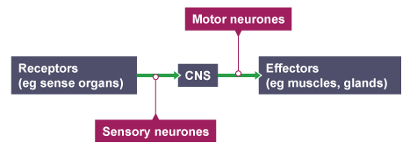
Hormones in human reproduction
The endocrine system is composed of glands which secrete chemicals called hormones directly into the bloodstream. The blood carries the hormone to a target organ where it produces an effect. Compared to the nervous system the effects are slower but act for longer.
Human endocrine system
The nervous system enables humans to react to their surrounding and to coordinate their behaviour.
The nervous system
Homeostasis is the regulation of the internal conditions of a cell or organism to maintain optimum conditions for function in response to internal and external changes.
Homeostasis
BU5 – Homeostasis and Response (Trilogy)

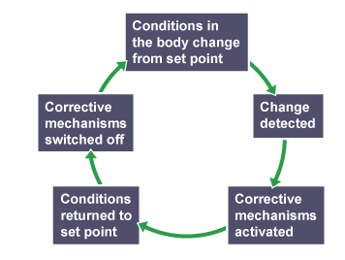
Things your body needs to control:
- Blood glucose concentration
- Body temperature
- Water levels
Negative feedback (HT)
Controlling blood glucose concentration
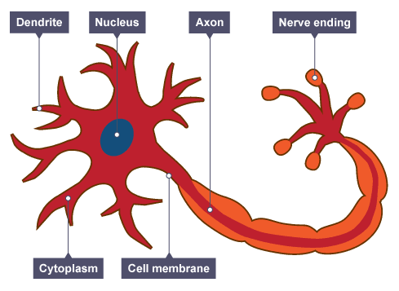
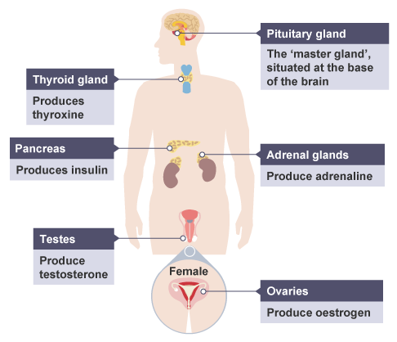

Contraceptives
Hormonal – Oral, injection
Non-hormonal – barrier method (condom), intrauterine devices, spermicidal agents, abstaining from intercourse, surgical method of sterilisation

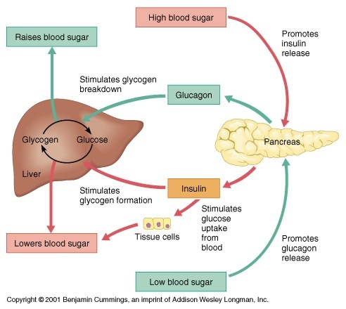
Treating infertility (HT)
Hormones can be used to treat infertility as used in IVF
- FSH and LH stimulate the maturation of eggs
- Eggs collected from mother and fertilised by sperm from father in a lab
- Fertilised eggs develop into embryos
- When they are tiny balls of cells, one or two embryos are inserted into the mother uterus

Controlling blood glucose concentration is monitored and controlled by the pancreas.

Reflexes are automatic and rapid and are important for protection. They do not involve the conscious part of the brain.

