- Lenses focus light through refraction.

- The principal focus, or focal point, is where the light is focussed – where the light rays meet.

- The focal length is the distance form the lens to this pont

**Uses of Waves**

**-** Waves **transmit** **energy**, not matter

- Particles vibrate at 90o to the direction of energy transfer in a **transverse** wave, and in the same direction as energy transfer in a **longitudinal** wave

Features and Properties

**Lenses (Physics Only)**

**PU6 – Waves**

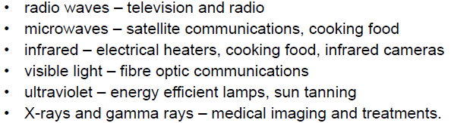

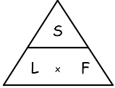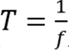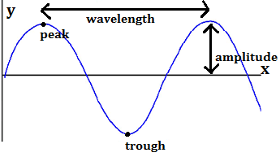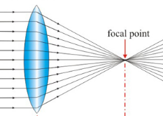

- Convex/ converging lenses bring light together

**- EM waves:** (HT need to know reasons for these uses)

Symbol:

**- Wavelength** (λ) = length of 1 full wave (m)

- **Amplitude** = max displacement from the middle

- **Frequency** (f) **=** number of waves /second (Hz)

- **Time period** (T) = time taken for 1 full wave

- **Speed** (s) = speed of the wave (m/s)

- **Electromagnetic waves** = a spectrum of tranvserse waves that travel at the same speed through a vacuum

**PHYSICS ONLY**

- **Reflection** = a wave hits a surface and bounces off at the **same** **angle**

- **Refraction** = a wave enters a new material. If the wave hits at 900, the direction does not change

**PHYSIC HT ONLY**

- **Ultrasound** = sound wave **above 20,000Hz**. Used to find distances (reflection off objects) and the structure of objects (reflection and refraction from the different materials inside them). This is safer than surgery or x-rays.

- **Seismic waves** = waves made by earthquakes. **P waves** are longitudinal and fast (push/primary), **S waves** are transverse and slow (shake/secondary). We use them to work out the structure of the Earth as **S waves cannot travel through liquids**.

****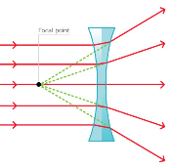

Symbol:

- Concave/ diverging lenses split light up



**Black Body Radiation (Physics Only)**

- Magnification of lenses is given by:

- The image and object height can be measured on a ray diagram drawn to scale:

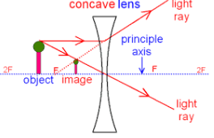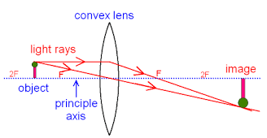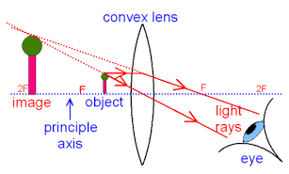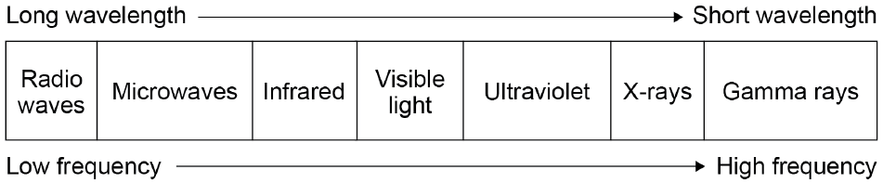

- All objects emit infra-red radiation, which is heat. The hotter they are, the moe they emit.

- Black bodies are perfect absorbers and emitters of infra-red radiation.

- (HT ONLY) Objects at constant temperature absorb and emit infra-red radiation at the same rate; if these are not equal its temperature will change. This applies to the Earth too.

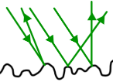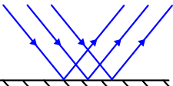



**Sound (Physics HT Only)**

- Lenses make an image of the object where the rays focus.

-A real image is when the image is in front of the lens.

- A virtual image is when the image is behind the lens.

- Sound waves can travel through solids as vibrations

- The human ear converts these virbations to electrical signals in the brain. The range of human hearing is 20Hz – 20,000Hz.

