Hydrocarbon + oxygen Carbon dioxide + water .



The main series of hydrocarbons contained in crude oil are called alk**anes.** The general formula for alkanes is CnH2n+2.

Alkenes are useful, because they are used to make polymers.

Alkenes contain a double bond.

General formula for an alkene is CnH2n

Combustion of hydrocarbons

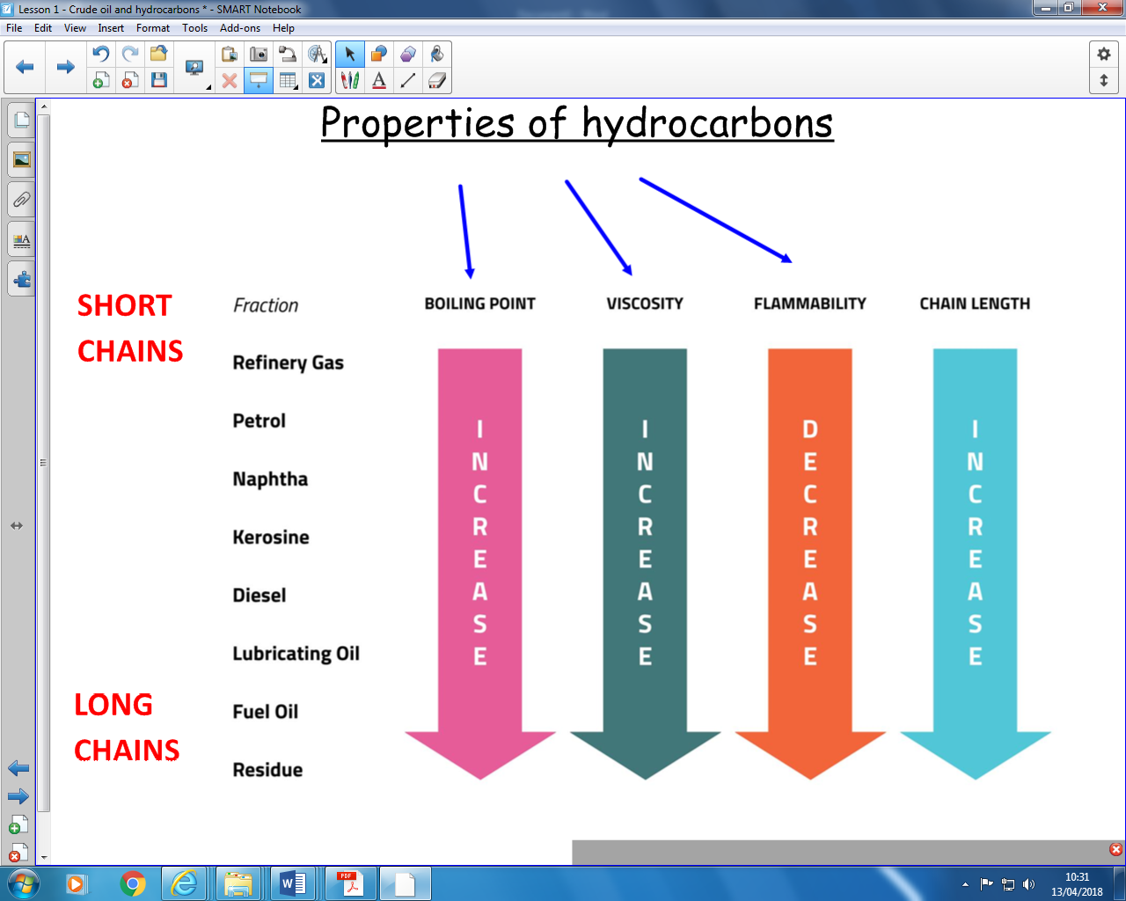

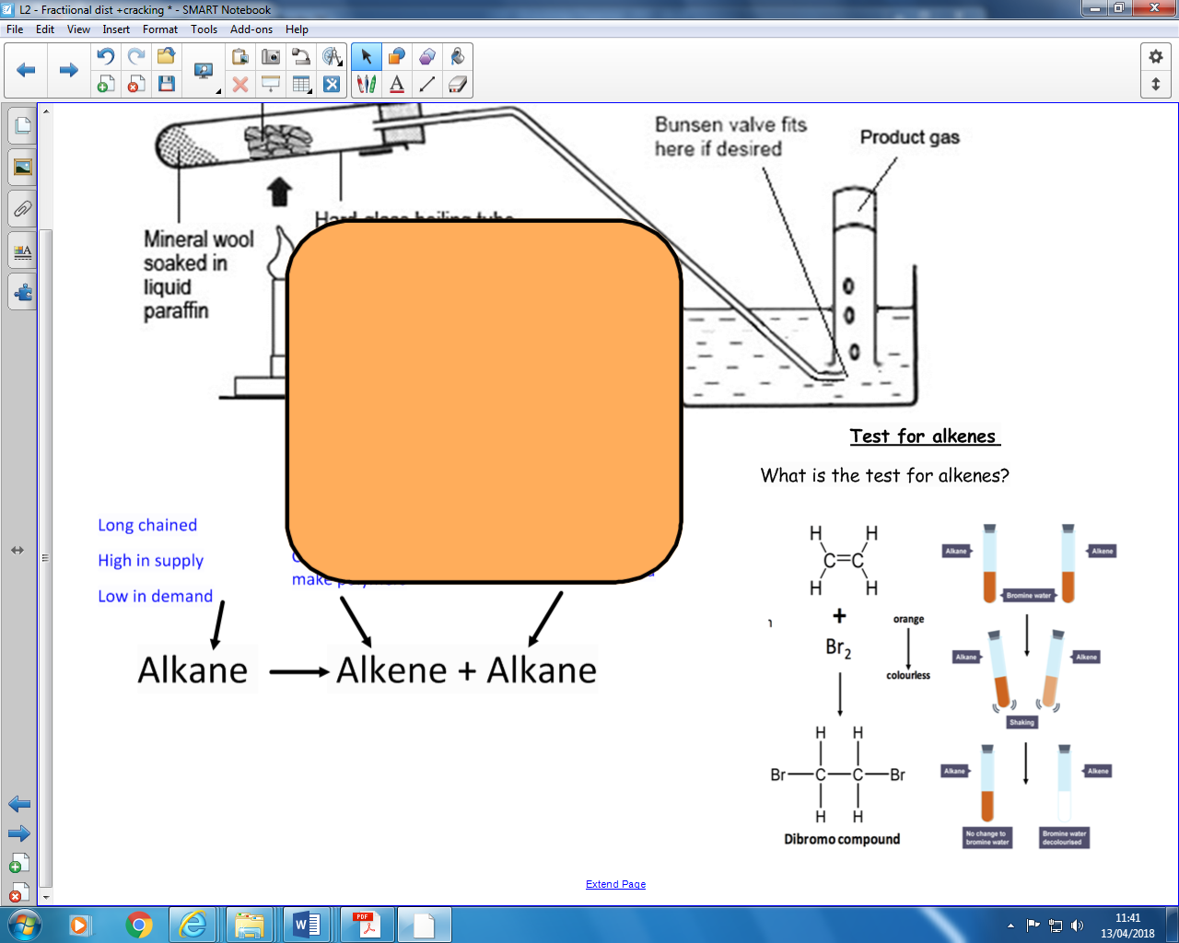

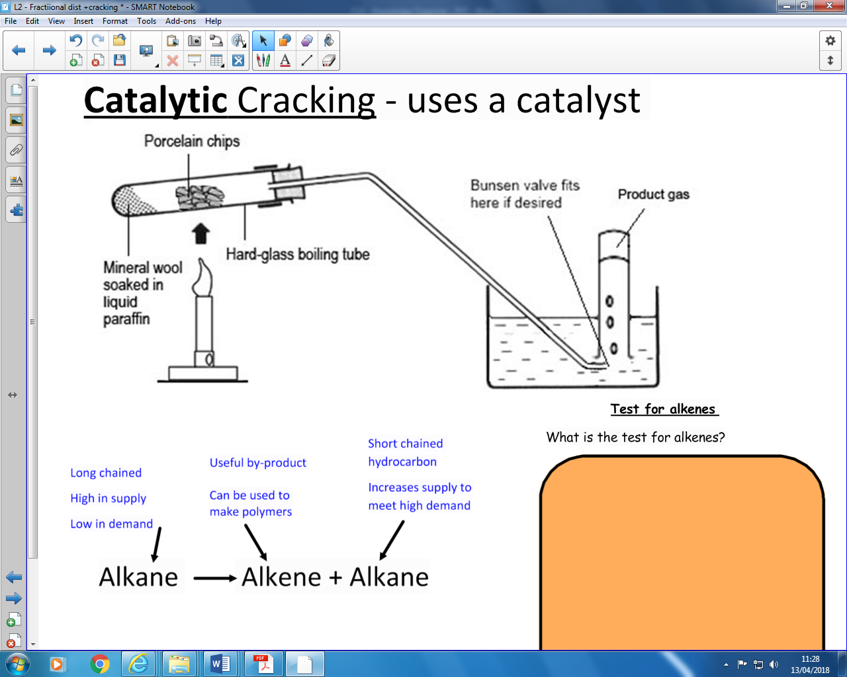

***Cracking***

Cracking allows large hydrocarbon molecules to be broken down into smaller alkane and alkene molecules to meet demand. Smaller hydrocarbons are more useful as fuels.

**Catalytic cracking** – catalyst and 500oC

**Steam cracking** – steam and 850oC



Properties of hydrocarbons





**Fractional distillation** separates oil based on boiling points.

***Short chained hydrocarbons***

Few intermolecular forces

Break easily

Boil easily

***Long chained hydrocarbons***

Many intermolecular forces

Hard to break

High boiling point

Fractional distillation

Alkanes

Formation of crude oil

**CU7 – Organic Chemistry**

Cracking

Crude Oil is made from the remains of

living **sea creatures** decayed in mud

millions of years ago