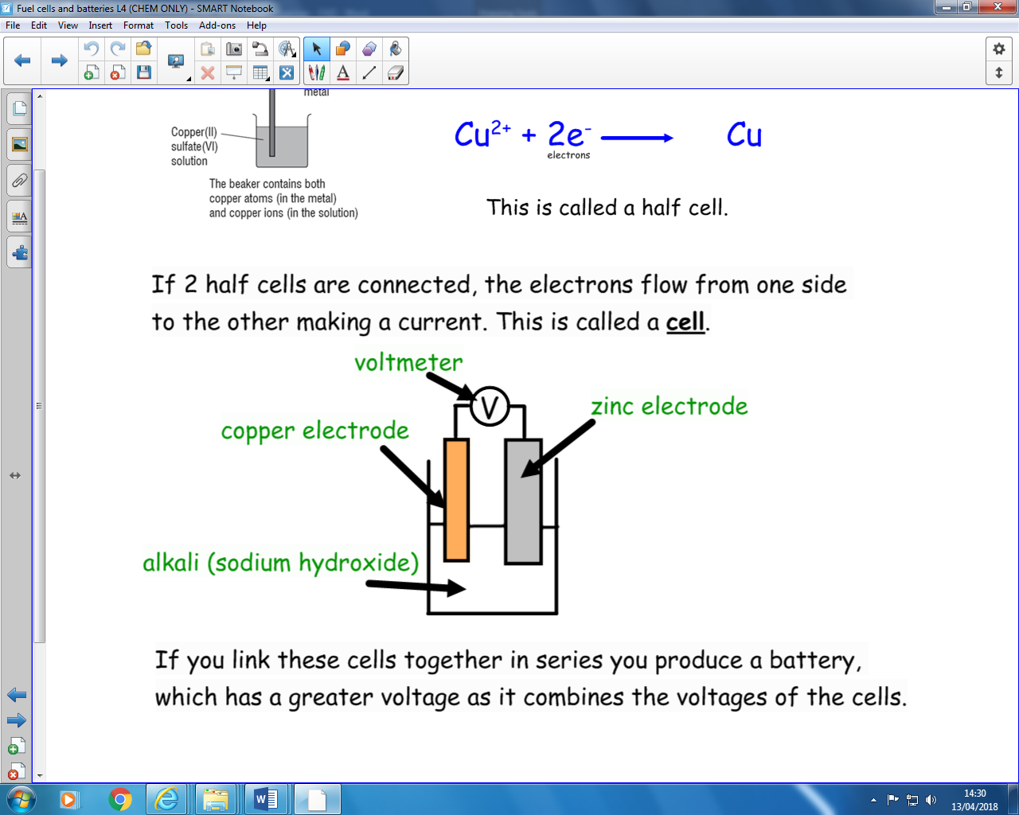

A metal in a solution of ions will react.

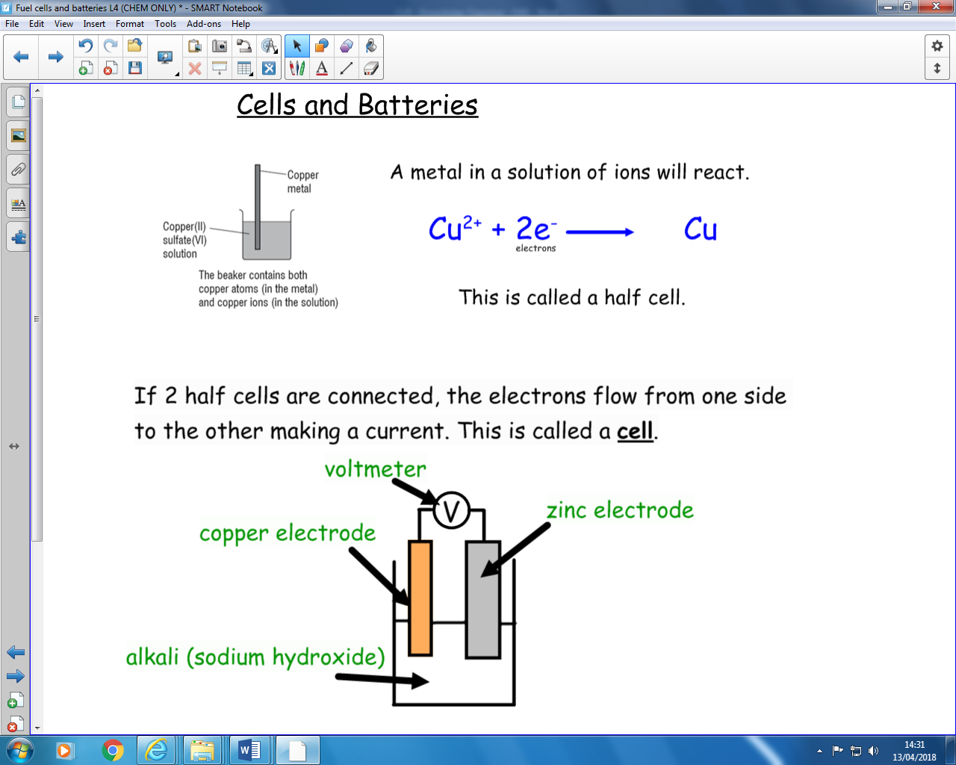

Cells and Batteries (CHEM)

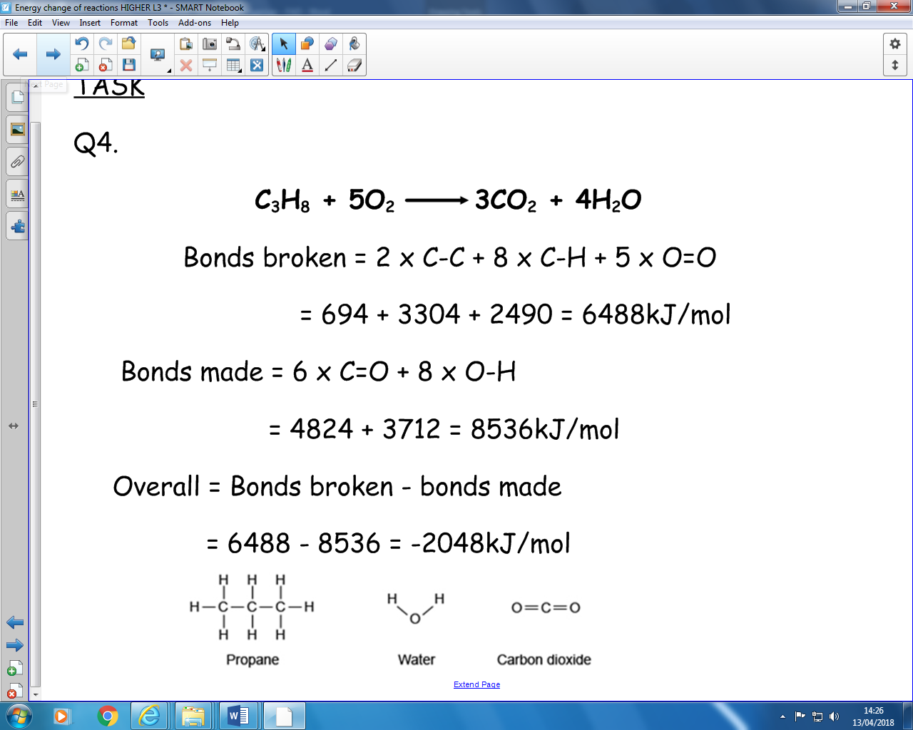

What happens in a reaction? (H)

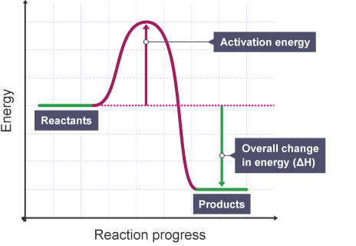

Reaction profiles

Overall = Energy to break bonds - Energy produced making bonds

+ tve answer = ENDOTHERMIC, -tve answer = EXOTHERMIC

If more energy is given out making bonds than is taken in breaking bonds a reaction will be exothermic overall.

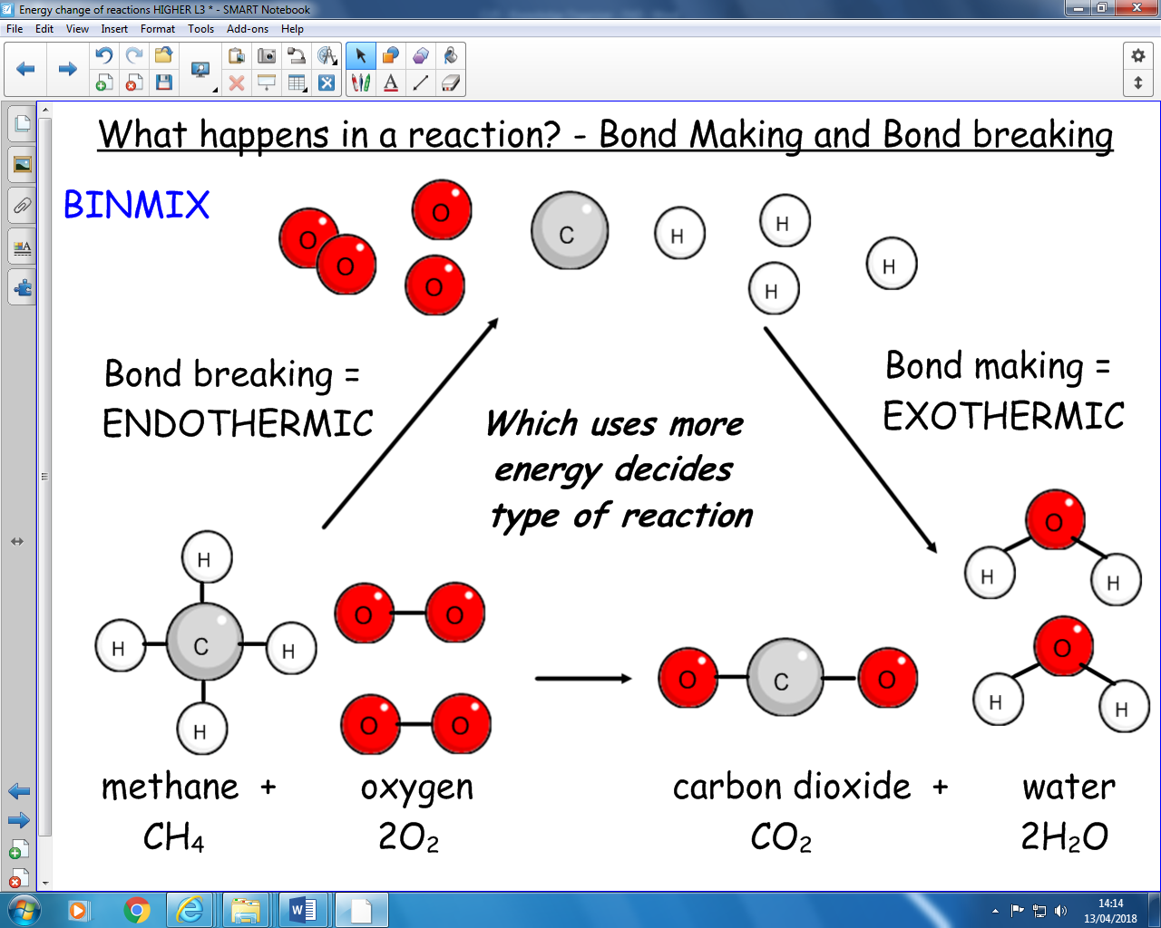

***Activation Energy:***

The collision between the reactants needs this much energy for it to be successful.

Particles need to collide with the minimum activation energy in order to react.

Takes energy from the surroundings, so temperature falls.

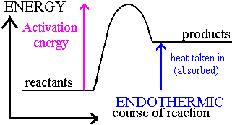

**Example;** Thermal decomposition and photosynthesis are endothermic.

Endothermic Reaction

Gives out energy to the surroundings, so temperature rises.

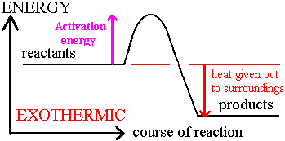

**Example;** Neutralisation between acids and alkalis is exothermic.

**CU5 – Energy Changes**

Exothermic Reaction

Example calculation (H)