Metals react with OXYGEN in OXIDATION reactions to form METAL OXIDES. Eg. Magnesium + oxygen 🡪 magnesium oxide

When oxygen is lost REDUCTION occurs.

K

Na

Li

Ca

Mg

Al

**C**

Zn

Fe

**H**

Cu

Ag

Au

Reactivity of metals

**Construct your equation:**

Mg + CuSO4 🡪 MgSO4 + Cu

**Remove spectator ions and re-write as an ionic equation:**

Mg + Cu2+ 🡪 Mg2+ + Cu

**Write half equations to show what happens to each species:**

Mg - 2e- 🡪Mg2+

Cu2+ + 2e- 🡪 Cu

**CU4 – Chemical Changes**

**O**xidation

**I**s

**L**oss

**R**eduction

**I**s

**G**ain

*of electrons*

Oxidation reduction (H)

Neutralisation and salts

Metals less reactive than carbon, can be extracted from their oxides by REDUCTION with carbon.

H+ + OH- 🡪 H2O

pH 1-6 acid

pH 8-14 alkali

pH 7 neutral

acid + alkali 🡪 salt + water

acid + metal oxide 🡪 salt + water

acid + metal carbonate 🡪 salt + water + carbon dioxide

Metal + acid 🡪 salt + hydrogen

**Making soluble salts**: Heat acid + insoluble solid(metal hydroxide/oxide/carbonate)

React, until no more reacts – to excess

Filter using filter paper and funnel.

Evaporate liquid, leave to crystallise for 24hrs.

eg. copper sulfate crystals

Displacement occurs when a more reactive substance takes the place of a less reactive substance eg**.**

Magnesium + copper sulfate 🡪 magnesuim sulfate + copper

nitric acid – nitrate

hydrochloric acid – chloride

sulfuric acid - sulfate

Strong and weak acids (H)

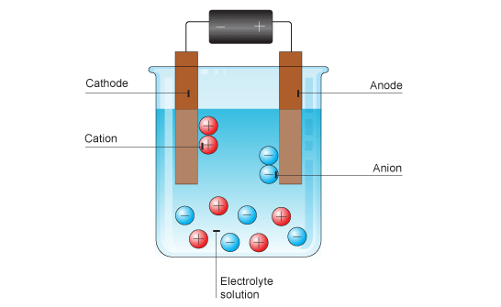[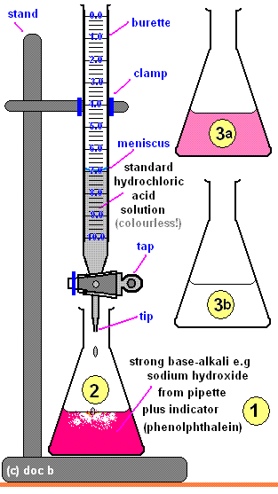](https://www.google.co.uk/url?sa=i&rct=j&q=&esrc=s&source=images&cd=&cad=rja&uact=8&ved=2ahUKEwid1qfa2c7aAhVLtBQKHUxSAr8QjRx6BAgAEAU&url=https://www.pinterest.com/pin/563442603365925242/&psig=AOvVaw2FPyEFvCdZ4Cf7Rcz0m_BK&ust=1524514627743446)

Electrolysis of molten ionic compounds

CATHODE = metal produced

ANODE = non-metal produced

eg lead bromide

Electrolysis to extract metals

CATHODE =metal produced

ANODE = oxygen produced

eg Aluminium (cryolite is added to lower the melting point)

Electrolysis of aqueous solutions

CATHODE = Hydrogen produced (unless metal is less reactive than hydrogen)

ANODE = Oxygen produced (unless halogens are present then they form)

Electrolysis

**P**ositive

**A**node

**N**egative

**I**s

**C**athode

And remember – cations are pussytive



At the ANODE negative ions lose electrons and OXIDATION takes place.

At the CATHODE positive ions gain electrons and REDUCTION takes place.

Used to determine the exact amount of acid required to neutralise a specific amount of alkali.

Concentration can then be calculated using:

moles = mass/Mr

conc = moles/ vol

Titrations (CHEM TRIPLE)

Strong acids totally/completely/fully ionise in water eg HCl 🡪 H+ + Cl -

Weak acids do not fully ionise, they partially ionise. Eg CH3COOH [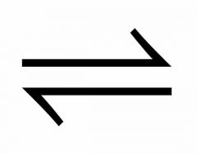](http://www.google.co.uk/url?sa=i&rct=j&q=&esrc=s&source=images&cd=&cad=rja&uact=8&ved=2ahUKEwj1zaf1w8HaAhVoKsAKHbgyCagQjRx6BAgAEAU&url=http://www.cram.com/flashcards/reversible-reactions--8065797&psig=AOvVaw1sFiE9q4qAfOGldudd4zUb&ust=1524062105115623) H= + CH3COO-