Some microorganisms (e.g. Bacteria) are known as **extremophiles** – They’re adapted to live in EXTREME conditions. E.g. High temperatures (hot volcanic vents)

HINT: Pyramids of biomass are always pyramid in shape (big to small).

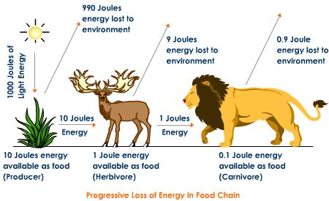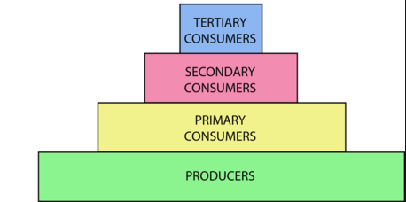

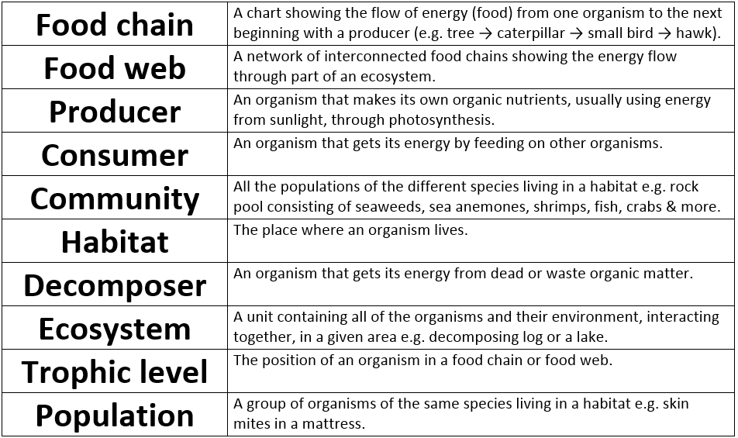

A typical quadrat is 1 m × 1 m, or 1 m2. Its area might be small compared to the area of a field.

For example, there are 4 dandelion plants inside a 1 m2 quadrat. The whole field is 50 m2 in area, the estimated population size of dandelions in the field would be:

4 × 50 = 200

When using a quadrat:

* It should be placed **randomly**so that a representative sample is taken
* The **validity** and **reproductibility** of the results increases as the results from more quadrats are analysed

Adaptations could be **structural** (features of an organism’s body structure such as colour/shape), **functional** (happen inside the organism’s body - poison) or **behavioural** (the way they behave, such as migration).

Only about 10% of biomass from each trophic level is transferred to the level above it. LOSSES are due to:

- Not all the ingested (eaten) material is absorbed. Some is egested as faeces.

- Some absorbed material is lost as waste, such as carbon dioxide and water in respiration.

**Trophic levels (BIO only)**

**Quadrat sampling -**

**Biodiversity**

**Recycling materials**- Decomposers play a very important role here by returning carbon to the atmosphere as carbon dioxide and mineral ions to the soil.

**Food chains**

Biodiversity is the variety of all the different species of organisms on earth, or within an ecosystem.

All food chains begin with a producer that synthesises (makes) molecules – usually a plant that makes glucose in photosynthesis.

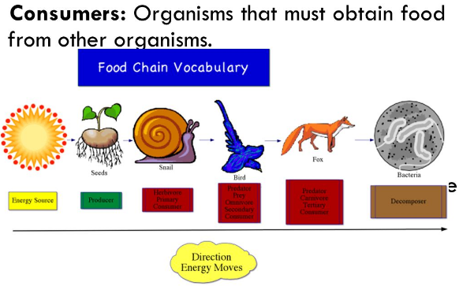

Microorganisms called decomposers are important in the breakdown/decay of plant and animal waste (organic material).

The rate (speed) of decay is affected by:

-Temperature

-Oxygen availability

-Water availability

-Number of decay microbes.

**Abiotic and Biotic**

Condensation = Gas to Liquid. Evaporation = Liquid to gas. Precipitation = Any form of water that falls from the sky (rain, snow, sleet)

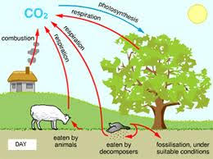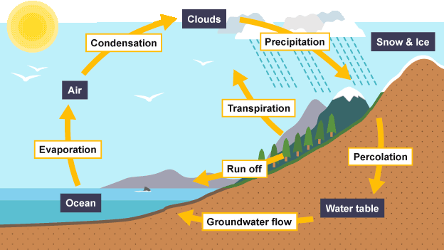

**Adaptations –** Features that allow organisms to survive in a particular habitat.

Both living (biotic) and non living (Abiotic) factors can influence where organisms live.

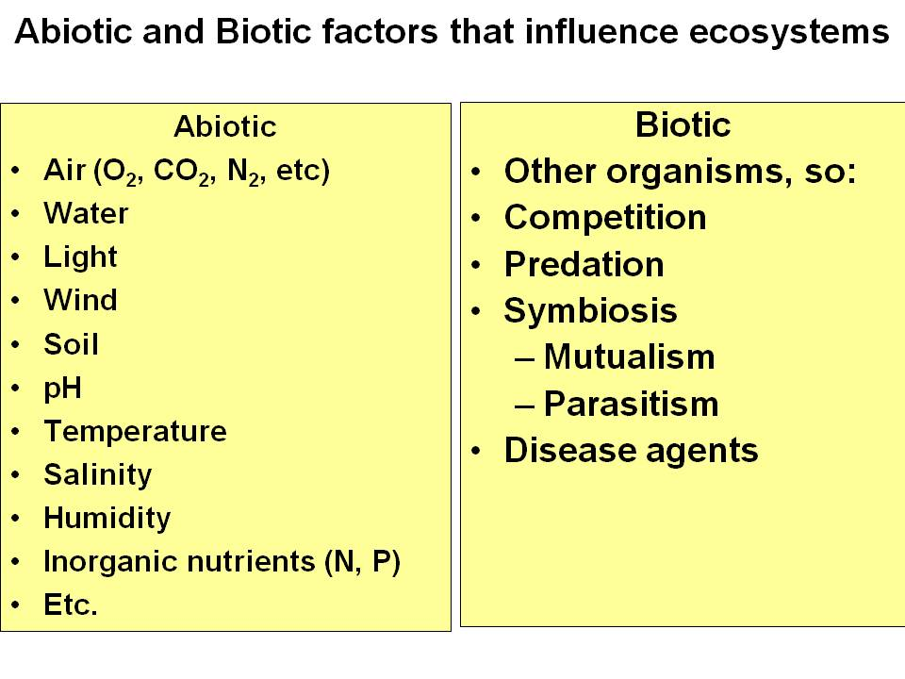

**BU7 – Ecology**