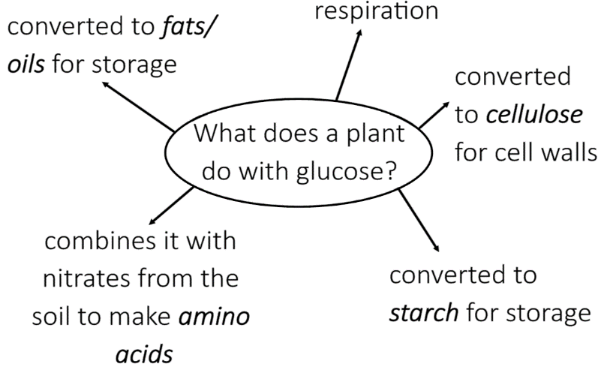

***Anaerobic*** respiration is carried out when there is a lack of oxygen.

In muscles it can be represented by the following equation:

**glucose 🡪 lactic acid**

In plants and yeast cells it can be represented by the following equation and is known as ***fermentation***.

**glucose 🡪 ethanol + carbon dioxide**

Photosynthesis is an ***endothermic*** reaction (takes in energy) that plants use to produce glucose.

It can be represented by the following equation:

**carbon dioxide + water 🡪 glucose + oxygen**

**6 CO2 + 6 H2O 🡪 C6H1206 + 6 O2**

Chlorophyll uses the energy from sunlight to carry out this reaction.

**BU4: Bioenergetics**

**Respiration**

**Photosynthesis**

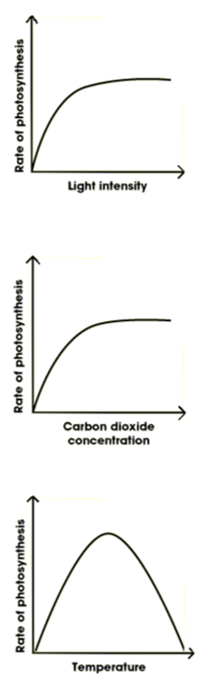

The rate of photosynthesis is determined by a variety of factors:

* temperature
* light intensity
* CO2 concentration
* the amount of chlorophyll

The graphs show how some of these factors affect the rate of photosynthesis.

***HT:*** If any of these factors are missing or reduced, they are known as ***limiting factors*** as they limit the amount of photosynthesis that can take place.

**Metabolism**

***Aerobic*** respiration is an ***exothermic*** reaction (gives out energy) that organisms use to produce energy.

It can be represented by the following equation:

**glucose + oxygen 🡪 carbon dioxide + water (+ energy)**

**C6H1206 + 6 O2 🡪 6 CO2 + 6 H2O (+ energy)**

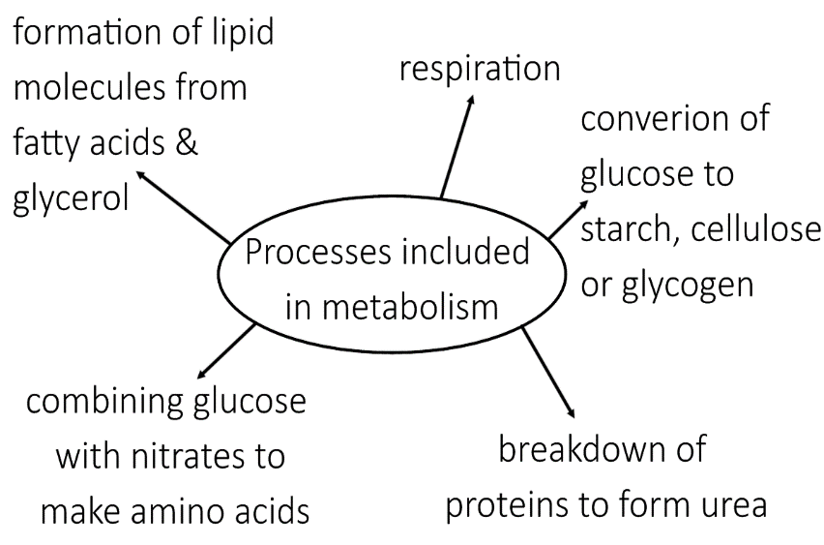

***HT:*** Anaerobic respiration leads to an ***oxygen debt***. This is the oxygen that is needed to break down all of the lactic acid produced during anaerobic respiration. Breakdown of lactic acid happens in the liver.

The body responds to exercise by:

* Increasing heart rate
* Increasing breathing rate
* Increasing breathing volume

All of these factors result in more oxygenated blood reaching the muscles so that they can carry out aerobic respiration.

Metabolism = The sum of all of the reactions taking place inside a cell of the body.

The energy from respiration is used by an organism for:

1. enzyme controlled reactions
2. synthesis of new molecules