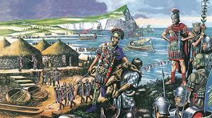
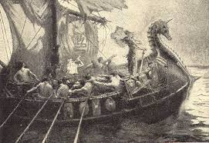
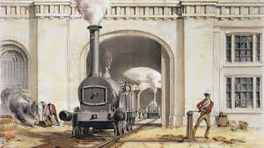
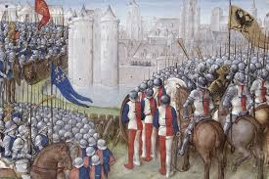
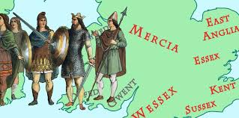
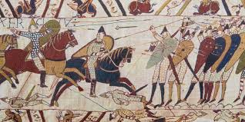
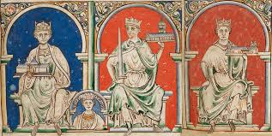
This booklet contains an overview of every topic you will study.

KS3: Year 7
Content
England and the Angevin Empire

Thomas Becket
Thomas Becket was close friends to Henry II. Once Henry II became king of England he employed Becket as his chancellor (advisor). When the Archbishop of Canterbury died Henry II thought Becket would be the best choice. Henry II believed this would allow him to control the church. However, Becket began to make decisions about the Church which eventually led to the two falling out. In December Becket was killed outside a church by 4 of the king’s knights.
Richard I and John I
Richard I was king following Henry II. However Richard ended spending most of his reign not in England but fighting in the Third Crusade. Despite not being in the country very often Richard has gone down in history as a great king with the nickname “Richard the Lionheart”. While Richard I was away he Arthur in charge of England but John kidnapped Arthur and declared himself king. John I continued to increase taxes and loose land (e.g. in France) which caused most the population to not like him. John I was seen as a greedy king. John I has gone down in history for the signing of the Magna Carta. John I was forced to sign this after his barons rebelled against him. The Magna Carta restricted the power that John I had.
Henry III
Henry III is king following John I. Because he was young the barons (who rebelled against John) controlled Henry III. Like John I Henry III’s rule was not popular because he broke many of the rules from the Magna Carta. This led to a rebellion against him where Henry III was forced to sign The Provisions of Oxford (which basically said the same as the Magna Carta). The rebellion was led by Henry III brother-in-law Simon de Montfort. Simon overthrew Henry III for only 1 year until Henry III’s son Edward I defeated Simon.
Key Events
- 1154 AD Henry II becomes King of England
- 1155 AD Thomas Becket became Chancellor
- 1162 AD Thomas Becket become Archbishop of Canterbury
- 29th December 1170 Thomas Becket is killed
- 1215 the John I signs the Magna Carta.
- 1216 Henry III is king at 9 years old
Key Individuals
Henry II – King of England
Thomas Becket – Archbishop of Canterbury
Richard I – King of England 1189- 1199
John I – King of England 1199- 1215
Henry III – King of England 1216-1272
Simon de Montfort – Lead’s rebellion against Henry III

