**Generators (Physics HT Only)**

- In the **Motor Effect**, putting current in (**electrical energy**) makes the wire spin (gives you **kinetic** **energy**)

- The **Generator Effect** is the same thing in reverse; making the wire spin (putting in **kinetic** **energy**) creates an electric current (gives you **electrical** **energy**).

Magnets

**- Magnets** attract/repel other magnets (like poles repel, opposite poles attract) or attract magnetic materials (**iron, nickel, cobalt, steel**)

- The force is strongest at the **poles**, and weaker further away

**PU7 – Magnets and Electromagnetism**

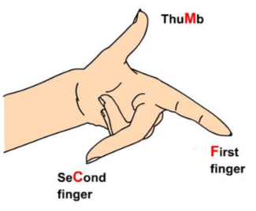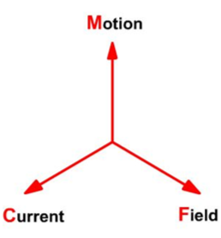

**Left Hand Rule (HT ONLY)**

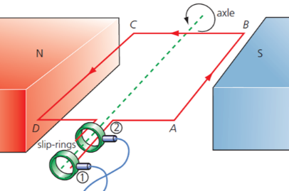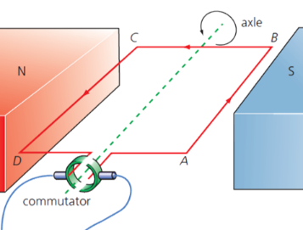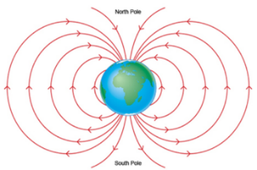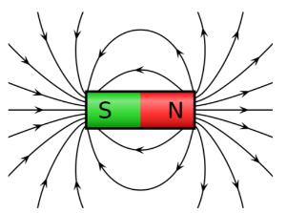

- Alternators use **slip** **rings** to generates **alternating current**

- **Dynamos** use commutators to generate **direct current**

If **a current carrying wire** is placed in a **magnetic field**, **a force will be exerted** on the wire. The Left Hand Rule helps you work out the direction of this force. The equation below tells you the size of the force.

- The region around a magnet where this force happens is the **magnetic field**. The direction of the field is **North to South** pole

- Compasses can be used to show the field of a bar magnet and the Earth

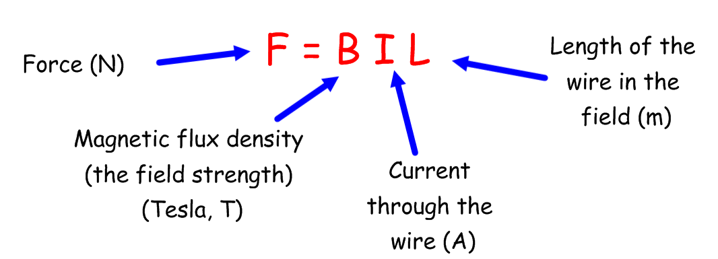

**Electromagnets**

**The Motor Effect (HT Only)**

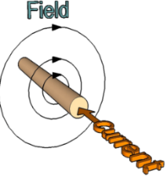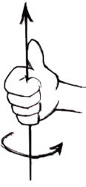

**Transformers (Physics HT Only)**

- Microphones use this effect; sounds makes a diaphragm move, which has a coil of wire on it. The wire moves around a magnet, creating a current.

When a wire conducts a **current**, a **magnetic** **field** is induced around the wire.

- Coiling the wire into a (**solenoid)** and using an **iron core** makes the field much stronger. This is called an **electromagnet**

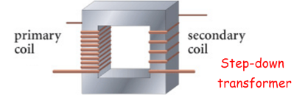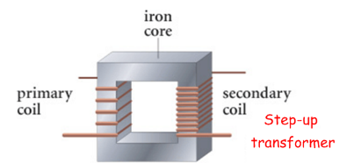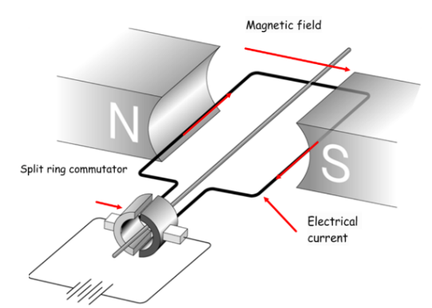

Transformers use different numbers of coils (Np and Ns) to raise and lower the potential difference (Vp and Vs). Step-up = higher PD, step-down = lower PD. This is used to make the National Grid more efficient.

- A **coil of current carrying wire** will spin in a **magnetic** **field** because of this force. The **split ring commutator** keeps it spinning the same way.

- Adding **more turns to the coil** of wire, using **stronger** (NOT BIGGER) magnets, and using a **bigger** **curent** will make it spin faster.

We can **increase its strength** by:

- Adding an **iron core/using a bigger one**

- Adding **more turns** to the coil of wire

- Using a **bigger electrical current**

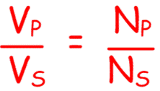

- Speakers use this effect; a cone has magnets on it, with wire wrapped around them. When a current passes through the wire, a force makes the magnets and the cone move, producing sound.