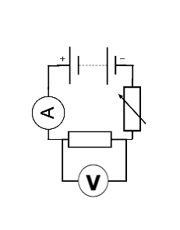

**Components**

**Static & Electric Fields**

**PU2 – Electricity**

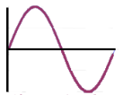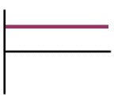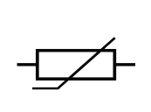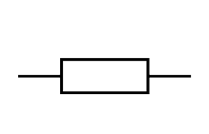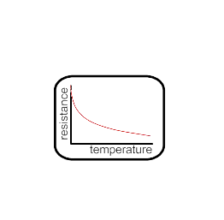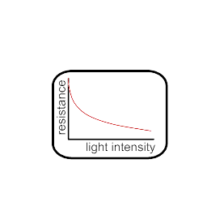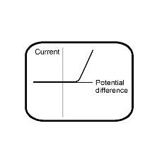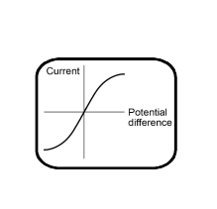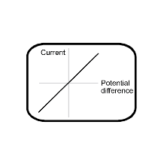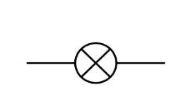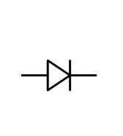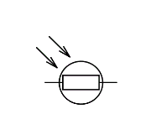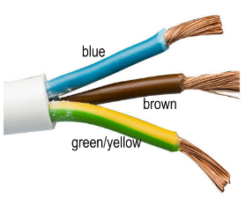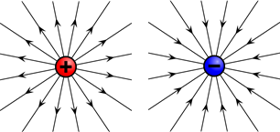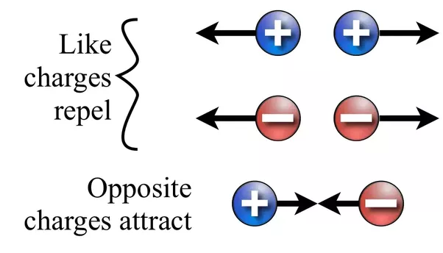

**A.C.** current changes direction and constantly changes size

**D.C.** fixed direction & size

# Mains Electricity – 230V, 50Hz a.c.

* Neutral (blue) 0V completes the circuit
* Brown (live) 230V carries the current
* Green & Yellow (Earth) 0V safety path for current

**Ohmic/Fixed Resistor** – current is DIRECTLY PROPORTIONAL to potential difference

**Filament Lamp** – resistance increases with more p.d. because it gets HOT

**Diode –** Only lets current pass in one direction

**Light Dependent Resistor (LDR)** – resistance DECREASES as LIGHT intensity INCREASES

**Thermistor** – resistance DECREASES as TEMPERATURE INCREASES

# Standard Test Circuit

|  |  |  |
| --- | --- | --- |
| Equations | Current, charge & time  *Q=It* | p.d., current & resistance  *V=IR* |
| Power 1  *P=IV* | Power 2  *P=I2R* |
| Energy, power & time  *E=Pt* | Energy, charge & p.d.  *E=QV* |

# Circuit Symbols

# Series- one loop; parallel separate loops

|  |  |  |  |
| --- | --- | --- | --- |
| Components in….. | Current, I | Potential difference, V | Resistance, R |
| Series | The same | Shared | Add together |
| Parallel | shared | The same | Less than the smallest resistance |

**Circuits & Mains**

# ELECTRIC FIELDS – area of force around a charged particle.

* Stronger near the charge, weaker further away

# **Creating static**

* FRICTION causes the TRANSFER of ELECTRONS from one material to another.
* The material that GAINS electrons becomes NEGATIVE
* The material that LOSES electrons becomes POSITIVE 