2) Change the pressure

Increasing pressure pushes the equilibrium position to the side with fewer gas molecules

Decreasing pressure pushes the equilibrium position to the side with more gas molecules

3) Change the temperature

If the forward reaction is exothermic increasing temperature pushes the equilibrium left to reduce the temperature

If the forward reaction is endothermic increasing temperature pushes the equilibrium right to increase the temperature

1) Change concentration Adding more reactant pushes the equilibrium position to the right. Adding more product pushes the equilibrium position to the left

**HIGHER ONLY**

**Factors affecting the position of the equilibrium**

**Reaching equilibrium**

*The point at which* ***the forward reaction is happening at the same rate as the backward****. This means the amount of reactants and products will stay the same however long the reaction is left. To reach equilibrium you must have a* ***closed system*** *where nothing can enter or leave.*

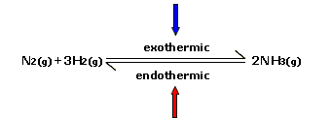

The reaction can go forwards and backwards at the same time – so reactants turn into products at the same time products turn into reactants.

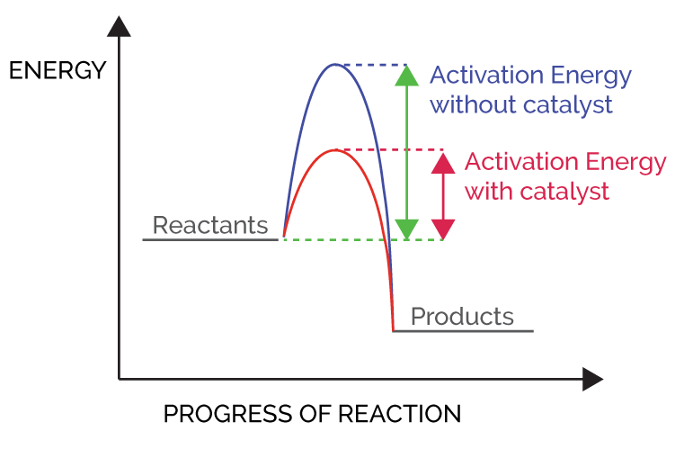

5) **Adding catalyst -** Speeds reaction up but *isn’t used up*. It reduces the activation energy so although the number of collisions is the same, more are *successful*.

4) **Increasing temperature –** Particles have more kinetic energy and move faster so more *frequent collisions* AND more of the collision have enough energy so more *successful collisions*- faster reaction.

*Factors affecting reaction rate:-*  1) **Increasing Concentration (in liquids) –** More particles in a the same volume so more *frequent collisions* = faster reaction 2) **Increasing Pressure (in gases) –** Same particles in a smaller volume so more *frequent collisions* = faster reaction1) 3) **Increasing Surface area (in gases) –** More particles to collide with so more *frequent collisions* = faster reaction

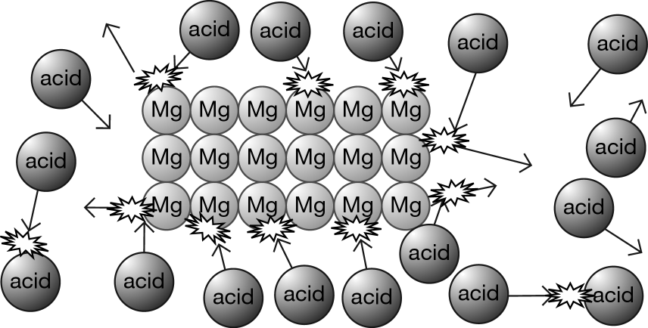

**The particles need to collide with enough energy for the collision to be successful. This is called *the activation energy*. The more frequent successful collision = faster reaction**

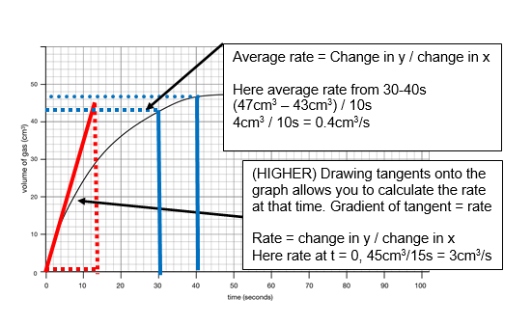

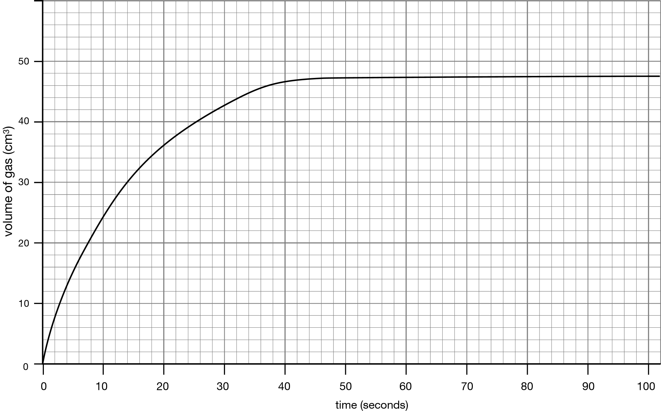

**Changing the shape of the graph** Higher rate = steeper line but stops at same volume Increasing limiting reactant = Stops at greater volume

The reaction stops when a reactant runs out (***limiting reactant***). This is shown on the graph when the line goes flat

**

*Measuring rates of reaction* - In a reaction that makes gas we measure the rate of a reaction by collecting the gas or measuring mass lost as gas produced escapes.

**Collision theory**

**CU6 – The rate and extent of chemical change**

**Reversible reactions**

**Measuring rates**