“How much nitrogen is required to produce 150g of ammonia”

**1. Produce a balanced symbol equation for the reaction:**

N2 + 3H2  2NH3

**2. Calculate the number of moles of the substance with known mass:**

n = m/Mr = 150/17 = 8.82 moles

**3. Compare the mole ratio from the reaction equation to find the number of moles of the substance with unknown mass:**

1 mole of nitrogen produces 2 moles of ammonia. Therefore, half the number of moles of nitrogen required. Moles of nitrogen = 4.41 moles.

**4. Calculate the mass of the substance with unknown mass.**

m = n x Mr = 4.41 x 28 = 123.48g

123.48g of N2 are required to produce 150g of NH3

**Atom Economy**



**Volumes of Gas (CHEMISTRY ONLY) (H)**

1 mole of any gas will always occupy the same volume, 24dm3.

**CHEMISTRY ONLY**

**Percentage Yield**



**Concentration (mol/dm3)**

**(CHEMISTRY ONLY) (H)**

For the moles of a substance in solution:

*Number of moles = concentration x volume*

Atomic Mass (RAM or Ar) and Relative Formula Mass (RFM or Mr)

Ar = mass number (larger number) from periodic table

Mr = sum of mass numbers for the given molecule. E.g H2O = 1+1+16 = 18

**Limiting and Excess Reactants (H)**

The limiting reactant is the reactant that is used up first in a chemical reaction, causing the reaction to stop. Any reactant(s) leftover are known as “excess” reactants.

**Moles and Avogadro’ Number**

The mole is a unit of measurement in chemistry. The number of atoms, ions, or molecules in one mole is equal to Avogadro’s Number: 6.02x1023.

Avogadro set his number so that 1 mole of a substance (6.02x1023 atoms) would have a mass in grams equal to its atomic or formula mass. **This results in the mole equation.**

Examples:

**“Calculate the number of moles in**

**320g of Fe2O3”:**

Mr of Fe2O3 = 56+56+16+16+16 = 160

n = m / Mr = 320/160 = 2 moles of Fe2O3

**“Calculate the mass of 4 moles of CO2”**

Mr of CO2 = 12+16+16 = 44

m = n x Mr = 4 x 44 = 176g of CO2

Mass cannot be created or destroyed. When mass appears to be gained or lost in a chemical reaction, this is gain from, or lost to, the surroundings.

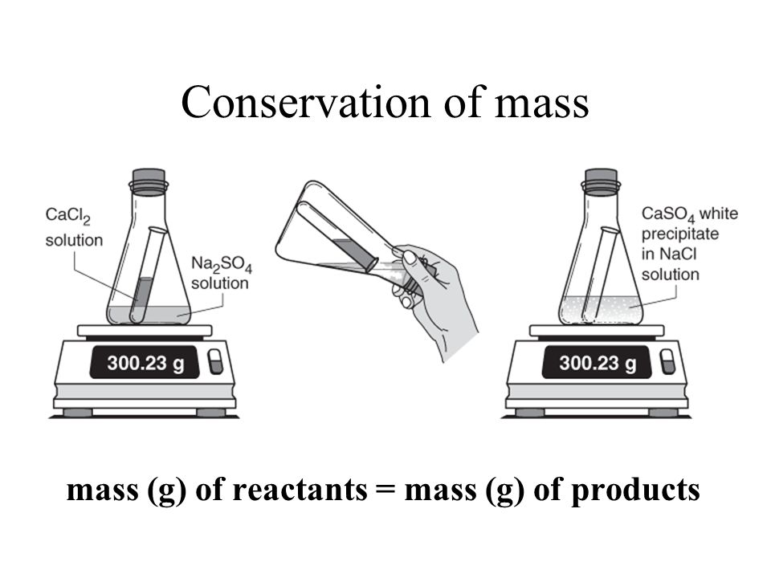

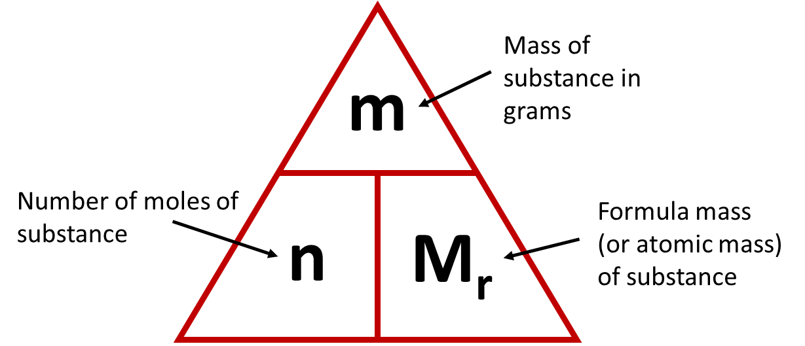

**Reacting Masses Example (H)**

**Conservation of Mass**

**CU3 – Quantitative Chemistry**

**Mole Calculations (H)**