***Alloys***

Alloys are mixtures of metals. The different sized atoms of other metals distort the structure and stop the layers sliding over one another. Alloys are harder and stronger than pure metals.

The atoms in metals are in layers which can slide over each other, this makes it possible to bend them into shape.

Properties

Metallic bonding is the electrostatic attraction between positive metal ions and a ‘sea’ of delocalised electrons.

Properties

***Ionic Compounds-***

High melting point – Strong interactions = Lots of energy to break.

No electrical conductivity - No charged particles free to move. Conducts when molten or dissolved due to free ions moving.

***Covalent Compounds-***

Low melting point - Weak interactions can be easily broken at low temperatures.

No electrical conductivity - No charged particles free to move

***Fullerenes***

It contains 60 c atoms, each of which is bonded to 3 others by 2single bonds and 1 double bond.

[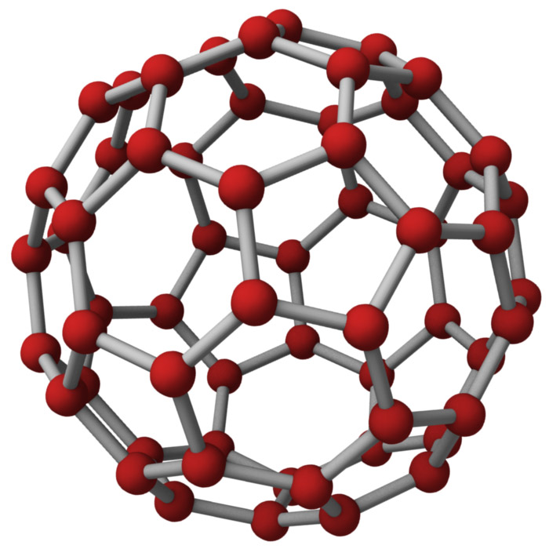](http://www.jameshedberg.com/img/samples/c60-buckyball-atoms-red.jpg)

***Graphite***

Each C joins to 3 others 1 free electron per carbon. Soft and slippery because layers can slide over each other Good electrical conductor

[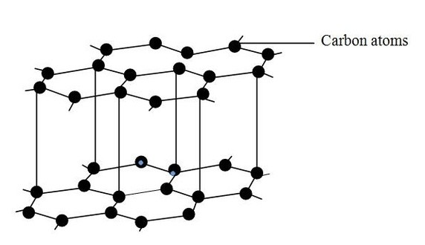](https://i.stack.imgur.com/dqwRb.jpg)

***Diamond***

Each C joins to 4 others. VERY hard, No electrical conductivity because no free mobile electrons.



Allotropes of Carbon.





***Metallic Bonding***

High melting and boiling points - Strong attractions are hard to break

Conducts Electricity - Delocalised electrons are free to move.

Two non-metals bond together and share electrons to get a full outer shell. The new particles formed are neutral.



Covalent bonding

A metal and non- metal combine together to make an ionic bond. i.e NaCl

Metallic Bonding



**CU2 – Bonding, structure and properties**

Ionic bonding

Alloys