Copper ores are finite so can be extracted from from low grade copper ores by:-

**Methods**:-

1. ***Bioleaching*** – Bacteria separate pure copper from copper compounds in ore.
2. ***Phytomining*** – Plants grown in copper based soils and take in copper. Plants are burnt so ash contains soluble copper compounds

Some aspects of the assessment can be easily quantified, E.g. amount of energy used, amount of pollutant made etc. However other aspects, such as the impact of pollution are much harder to measure and are based on a person’s opinion. Therefore LCAs can be biased and used by companies to advertise their products

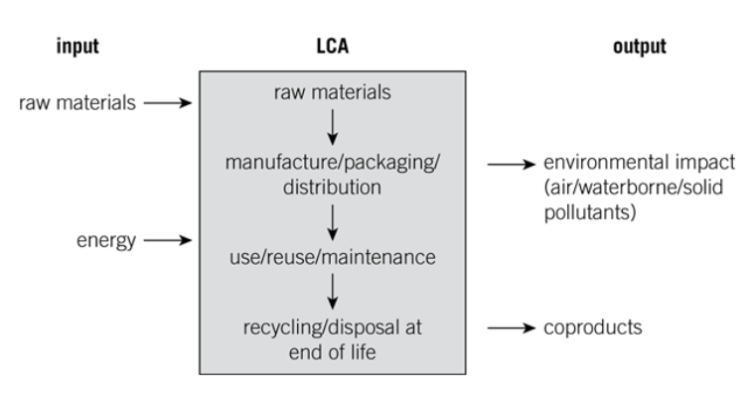

Looks at four stages of a products production and use to assess it’s impact on the environment.

Waste water is produced from houses (E.g. *toilets*), agriculture and industry. Contains organic matter, harmful microbes and harmful chemicals that must be removed before it can be safely released into the environment

1. Filtered through screens to remove large quantities of solid waste
2. Sedimentation – the sewage sits in tanks. The heavier solids sink to produce **sludge** while the light, **effluent** floats on top.
3. The **effluent** is removed and treated by **biological aerobic digestion**. In this process air is pumped into the **effluent** so aerobic bacteria can breakdown organic matter and other microbes, making the water clean enough to be released. Sometimes chlorine / ozone / UV treatment is used before release to further sterilise water
4. The **sludge** undergoes **anaerobic digestion**, with anaerobic bacteria breaking it down to release methane gas. The ***methane*** gas can be used as an energy source while the **digested waste** is used as ***fertiliser.***

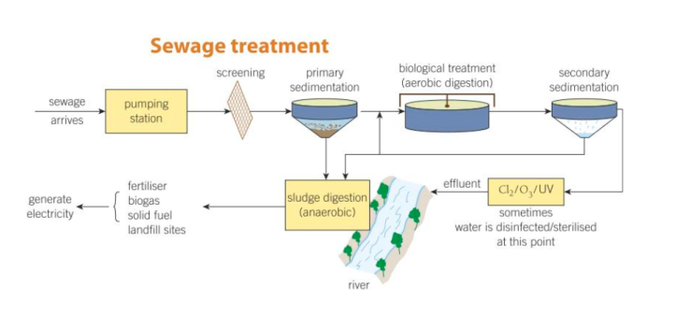

**In dry countries** –***Desalination*** (salt removal) of seawater produces potable water by either:-

1. ***Distillation*** – Seawater boiled to make steam, which is condensed, producing pure water
2. ***Reverse osmosis*** – Seawater forced through a membrane that only allows the water through and not the salt, producing potable water

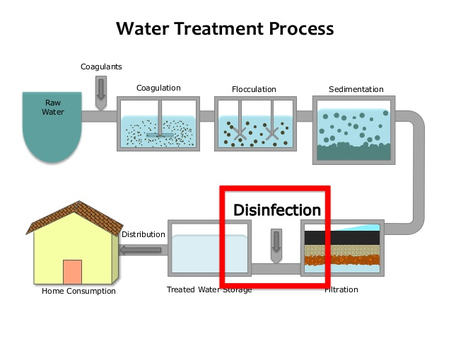

**In the UK** - Obtained by treating water from rivers, lakes, reservoirs and aquifers as follows:-

1. *Wire mesh is used to filter out large twigs.*
2. *The water then stands in sedimentation tanks, so solid settles out and is removed.*
3. *Chemical coagulants are added to clump small pieces of solid so they can be removed.*
4. *Last solid removed using sand and gravel filters.*
5. *Sterilised to remove the microbes using either chlorine, ozone or UV ligh.t*
6. *The pH is then tested before distribution.*

***Water that is of good enough quality to drink, although it does not mean it is chemically pure***

**Other methods of metal extraction (Higher only)**

**Treating Waste water**

**CU10 – Using resources**

**(All Courses)**

**Life Cycle Assessments**

**Potable water**