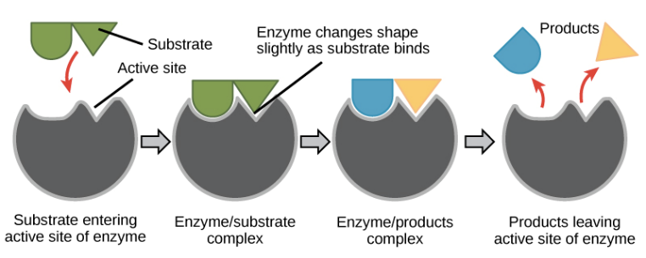
Non-Communicable Diseases
The Heart & Blood
Enzymes
BU2- Organisation
Disease | Cause | Treatments
Type 2 Diabetes | High Carbohydrate/ sugar diet | Medication  Exercise  Diet
Chronic Heart Disease | No exercise, high fat diet. Poor lifestyle | Exercise, Diet, Statins, Stents, Valve Replacement, Heart Transplant
Obesity | Poor diet, no exercise, poor lifestyle | Exercise, balanced diet, Gastric band
Liver Cirrhosis | Excessive alcohol | Stop drinking alcohol, medication, liver transplant

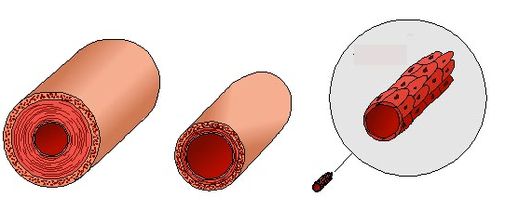
Enzyme | Where is it found | breaks down | Breaks down into
Carbohydrase | Mouth, Pancreas, Small intestine | Carbohydrates | Glucose
Protease | Mouth, Stomach, Small Intestines, Pancreas | Proteins | Amino acids
Lipase | Pancreas, Small intestine | Fats | Glycerol & Fatty acids
Arteries | Veins | Capillaries
Carry blood away from heart | Carry blood towards heart | Diffusion of substances
Narrow lumen, thick walls for high pressure | Thin walls, wider lumen, valves to prevent back flow | One cell thick, thin to allow for the diffusion of substances
Double Circulatory System
The right side of the heart is pumping blood from the heart to the lungs.
The left side of the heart is pumping blood to the body

Plant Structure & Function
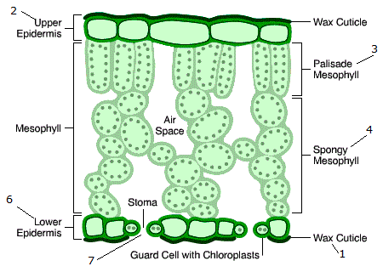
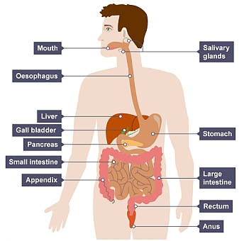

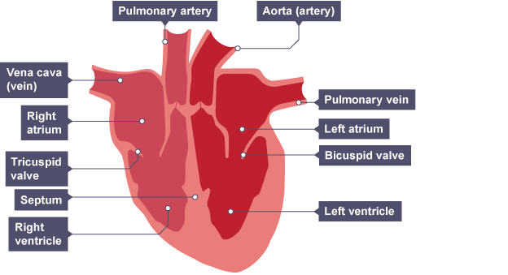
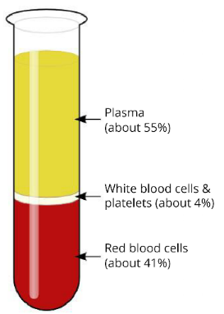
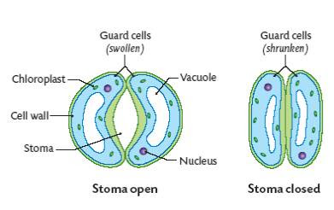
Composition of the blood
Plasma- contains dissolved substances, cells and cell fragments.
Red blood Cells- Contains haemoglobin that carries oxygen around the body.
White Blood Cells-Protect against pathogens
Platelets- Help the blood to clot

Active Transport- Movement of ions across a membrane from a low to high concentration.
Transpiration- is when a plant absorbs water in its roots.

